Name: Mohamad Akram

ID: 17P8070

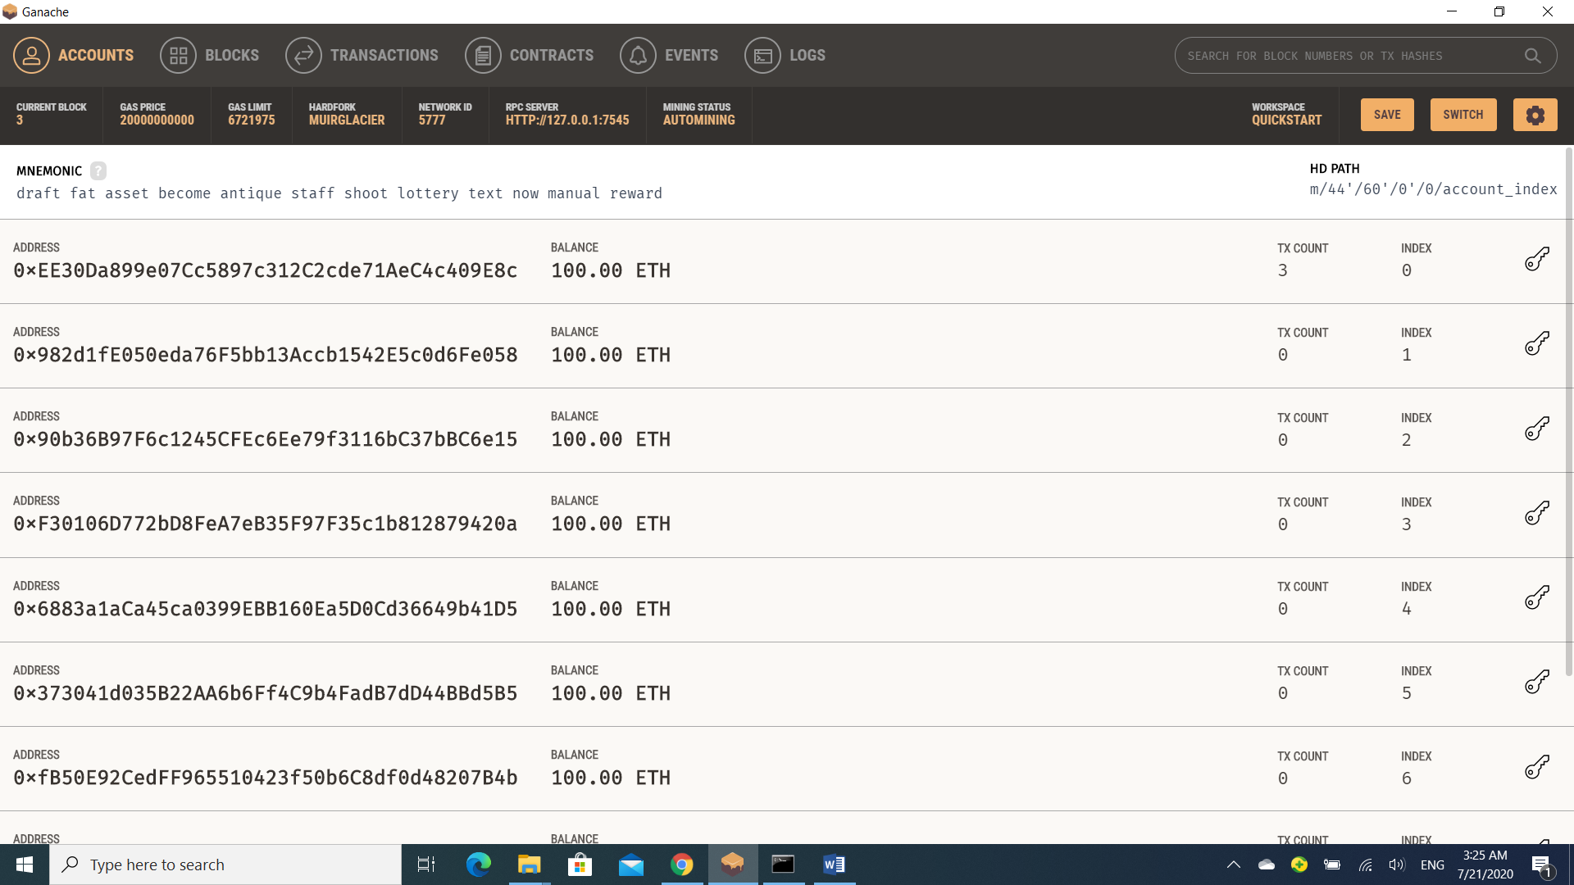1)Ganache server started

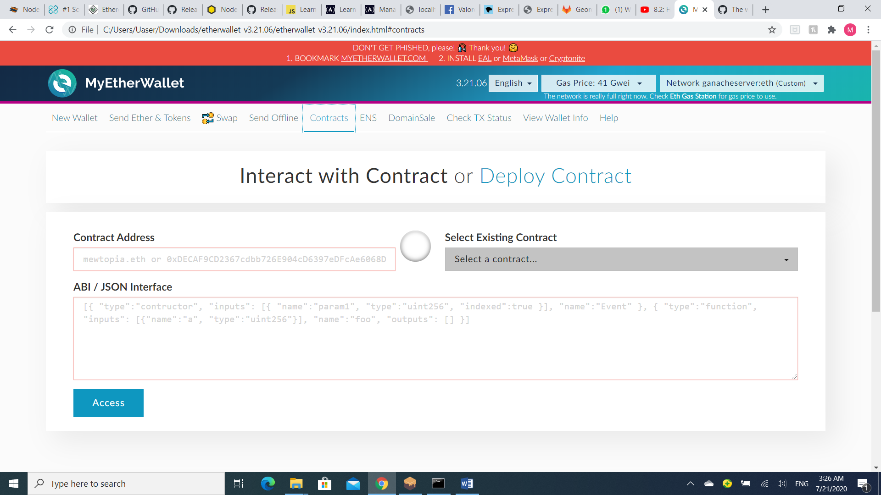2)mew account created and linked to the ganache network

3) use a contract to crypto kitties sales auction to bid using an account

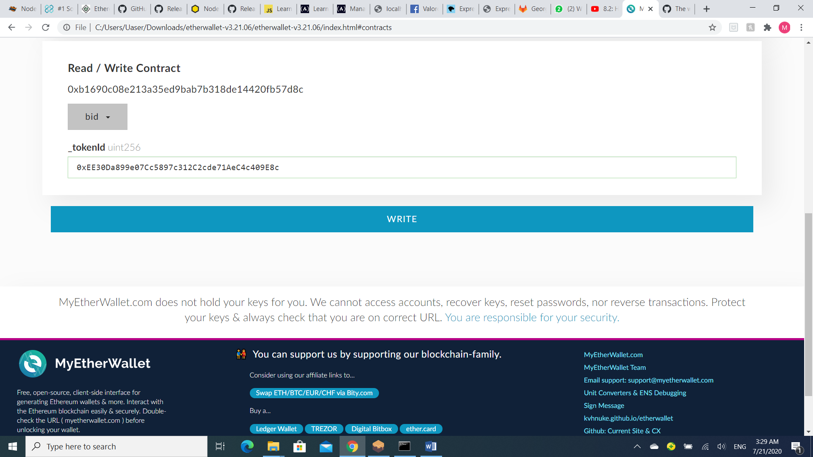

4) 10 eth are used to bid

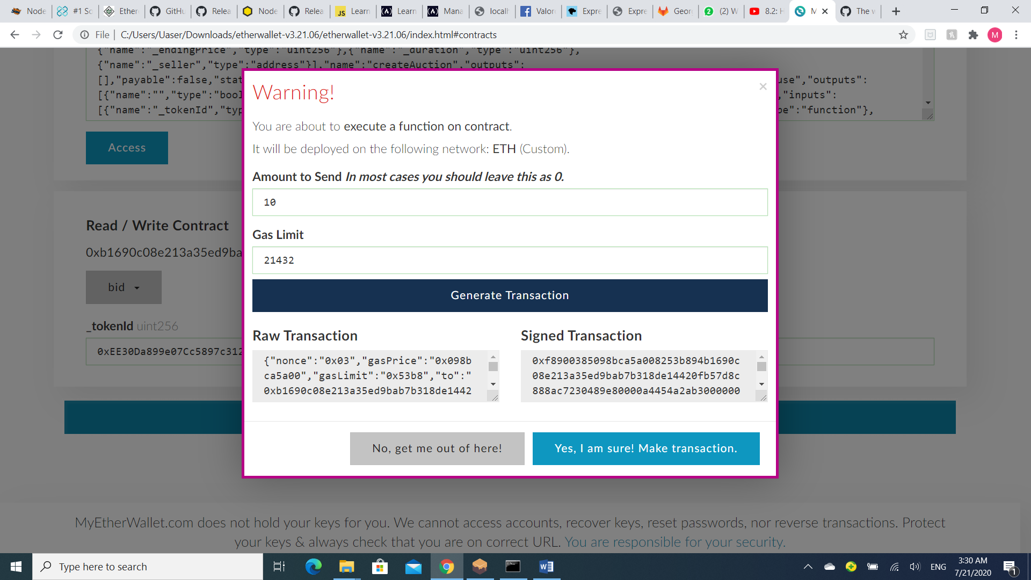

5) in ganache network check on eth for this account

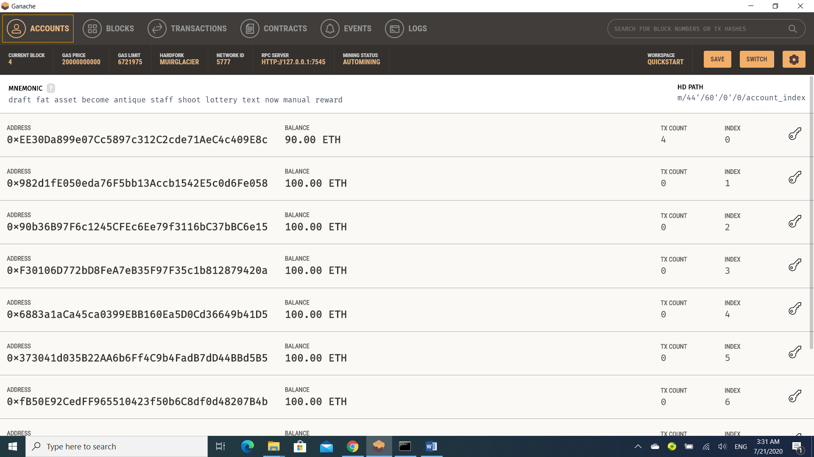

6) transactions menu shows the transaction that we preformed.

